Palindromic Primes
# Source: AI Source: Provided by: [Data Path: Persons Table -> ID Column: 1, Name_En Column: Motasem Essam] -> From: [ChatGPT] on [7/13/2026]
A palindromic prime (also called a palindrome prime) is a prime number that reads the same forward and backward in its decimal representation.
For example,
$$131$$
is a palindromic prime because
- it is prime, and
- reversing its digits gives
$$131,$$
which is identical to the original number.
Palindromic primes are studied in number theory, digit patterns, and computational mathematics.

Definition
# Source: AI Source: Provided by: [Data Path: Persons Table -> ID Column: 1, Name_En Column: Motasem Essam] -> From: [ChatGPT] on [7/13/2026]
A palindromic prime is a number that satisfies both of the following conditions:
- It is a prime number.
- Its decimal representation is a palindrome, meaning it reads the same from left to right and from right to left.

Rules for Palindromic Primes

1. The Number Must Be Prime
# Source: AI Source: Provided by: [Data Path: Persons Table -> ID Column: 1, Name_En Column: Motasem Essam] -> From: [ChatGPT] on [7/13/2026]
The number must have exactly two positive divisors:
$$1$$
and itself.
Example
$$131$$
is prime.

2. The Number Must Read the Same Forward and Backward
# Source: AI Source: Provided by: [Data Path: Persons Table -> ID Column: 1, Name_En Column: Motasem Essam] -> From: [ChatGPT] on [7/13/2026]
Reversing the decimal digits must produce the same number.
Example
$$727$$
reverses to
$$727.$$
Since the numbers are identical,
727 is a palindrome.

3. Both Conditions Must Be Satisfied
# Source: AI Source: Provided by: [Data Path: Persons Table -> ID Column: 1, Name_En Column: Motasem Essam] -> From: [ChatGPT] on [7/13/2026]
A number is a palindromic prime only if it is both
- prime, and
- a palindrome.
Example
$$121$$
is a palindrome,
but
$$121={11}^{2},$$
so it is not a palindromic prime.

4. Every Even-Length Palindromic Number Greater Than 11 Is Composite
# Source: AI Source: Provided by: [Data Path: Persons Table -> ID Column: 1, Name_En Column: Motasem Essam] -> From: [ChatGPT] on [7/13/2026]
Every palindrome having an even number of digits is divisible by
$$11,$$
except
$$11$$
itself.
Therefore,
$$11$$
is the only even-length palindromic prime.
Example
$$1221$$
is divisible by
$$11.$$
Therefore,
it cannot be a palindromic prime.

5. Most Palindromic Primes Have an Odd Number of Digits
# Source: AI Source: Provided by: [Data Path: Persons Table -> ID Column: 1, Name_En Column: Motasem Essam] -> From: [ChatGPT] on [7/13/2026]
Since even-length palindromes (except 11) are divisible by
$$11,$$
almost every palindromic prime has an odd number of digits.

6. Palindromic Primes Become Less Frequent
# Source: AI Source: Provided by: [Data Path: Persons Table -> ID Column: 1, Name_En Column: Motasem Essam] -> From: [ChatGPT] on [7/13/2026]
As numbers become larger,
palindromic primes become increasingly rare because they must satisfy both the palindrome and primality conditions.

7. It Is Unknown Whether Infinitely Many Palindromic Primes Exist
# Source: AI Source: Provided by: [Data Path: Persons Table -> ID Column: 1, Name_En Column: Motasem Essam] -> From: [ChatGPT] on [7/13/2026]
Mathematicians do not know whether infinitely many palindromic primes exist.
This remains an open problem.

First Palindromic Primes
# Source: AI Source: Provided by: [Data Path: Persons Table -> ID Column: 1, Name_En Column: Motasem Essam] -> From: [ChatGPT] on [7/13/2026]
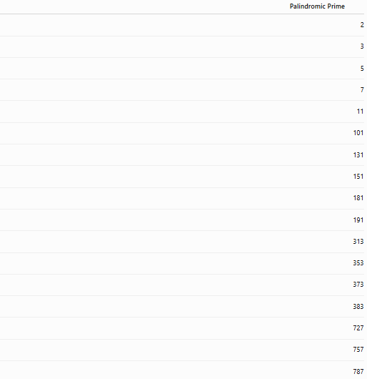
Palindromic Prime
2
3
5
7
11
101
131
151
181
191
313
353
373
383
727
757
787
797

Examples
# Source: AI Source: Provided by: [Data Path: Persons Table -> ID Column: 1, Name_En Column: Motasem Essam] -> From: [ChatGPT] on [7/13/2026]
Example 1
Determine whether
$$11$$
is a palindromic prime.
Reverse the digits:
$$11→11.$$
Since
$$11$$
is prime,
11 is a palindromic prime.

Example 2
Determine whether
$$131$$
is a palindromic prime.
Reverse the digits:
$$131→131.$$
Since
$$131$$
is prime,
131 is a palindromic prime.

Example 3
Determine whether
$$181$$
is a palindromic prime.
Reverse the digits:
$$181→181.$$
Since
$$181$$
is prime,
181 is a palindromic prime.

Example 4
Determine whether
$$121$$
is a palindromic prime.
Reverse the digits:
$$121→121.$$
Although
$$121$$
is a palindrome,
$$121={11}^{2}.$$
Therefore,
121 is not a palindromic prime.

Example 5
Determine whether
$$727$$
is a palindromic prime.
Reverse the digits:
$$727→727.$$
Since
$$727$$
is prime,
727 is a palindromic prime.

Example 6
Determine whether
$$1331$$
is a palindromic prime.
Reverse the digits:
$$1331→1331.$$
Since
$$1331={11}^{3},$$
it is composite.
Therefore,
1331 is not a palindromic prime.

Common Palindromic Primes
# Source: AI Source: Provided by: [Data Path: Persons Table -> ID Column: 1, Name_En Column: Motasem Essam] -> From: [ChatGPT] on [7/13/2026]
Some well-known palindromic primes are
$$2, \\ 3, \\ 5, \\ 7, \\ 11, \\ 101, \\ 131, \\ 151, \\ 181, \\ 191, \\ 313, \\ 353, \\ 373, \\ 383, \\ 727.$$

How to Determine Whether a Number Is a Palindromic Prime
# Source: AI Source: Provided by: [Data Path: Persons Table -> ID Column: 1, Name_En Column: Motasem Essam] -> From: [ChatGPT] on [7/13/2026]
- Reverse the decimal digits.
- Verify that the reversed number equals the original number.
- Test whether the number is prime.
- If both conditions are satisfied, the number is a palindromic prime.
Example
Check
$$353.$$
Reverse the digits:
$$353→353.$$
Since
$$353$$
is prime,
353 is a palindromic prime.

Real-Life Applications
# Source: AI Source: Provided by: [Data Path: Persons Table -> ID Column: 1, Name_En Column: Motasem Essam] -> From: [ChatGPT] on [7/13/2026]
Palindromic primes are primarily used in:
- Number theory research
- Computational mathematics
- Prime number searches
- Primality testing
- Algorithm development
- Mathematical software
- Computer science
- Mathematics education
- Recreational mathematics
- Research in digit-based number patterns

Real-Life Examples
# Source: AI Source: Provided by: [Data Path: Persons Table -> ID Column: 1, Name_En Column: Motasem Essam] -> From: [ChatGPT] on [7/13/2026]
1. Number Theory Research
Researchers study palindromic primes to understand the relationship between symmetry and prime numbers.

2. Computational Mathematics
Algorithms efficiently generate palindromic numbers and test them for primality.

3. Prime Number Searches
Large palindromic numbers are tested to discover new palindromic primes.

4. Mathematical Software
Computer algebra systems generate and verify palindromic primes.

5. Recreational Mathematics
Palindromic primes are among the most famous examples of numbers possessing both symmetry and primality.

6. Mathematics Education
They demonstrate how digit symmetry can combine with prime-number properties.

Common Mistakes
# Source: AI Source: Provided by: [Data Path: Persons Table -> ID Column: 1, Name_En Column: Motasem Essam] -> From: [ChatGPT] on [7/13/2026]
- Confusing palindromic primes with emirp primes.
- Assuming every palindrome is prime.
- Forgetting that
$$11$$
is the only even-length palindromic prime.
- Assuming every odd-length palindrome is prime.
- Ignoring the primality test.

Key Points
# Source: AI Source: Provided by: [Data Path: Persons Table -> ID Column: 1, Name_En Column: Motasem Essam] -> From: [ChatGPT] on [7/13/2026]
- A palindromic prime reads the same forward and backward.
- The number must also be prime.
- Every even-length palindrome greater than
$$11$$
is divisible by
$$11.$$
- Therefore,
$$11$$
is the only even-length palindromic prime.
- Most palindromic primes have an odd number of digits.
- Whether infinitely many palindromic primes exist remains an open problem.

Palindromic Primes vs. Emirp Primes
# Source: AI Source: Provided by: [Data Path: Persons Table -> ID Column: 1, Name_En Column: Motasem Essam] -> From: [ChatGPT] on [7/13/2026]
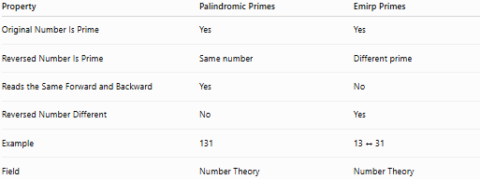
Property | Palindromic Primes | Emirp Primes
Original Number Is Prime | Yes | Yes
Reversed Number Is Prime | Same number | Different prime
Reads the Same Forward and Backward | Yes | No
Reversed Number Different | No | Yes
Example | 131 | 13 ↔ 31
Field | Number Theory | Number Theory

Conclusion
# Source: AI Source: Provided by: [Data Path: Persons Table -> ID Column: 1, Name_En Column: Motasem Essam] -> From: [ChatGPT] on [7/13/2026]
A palindromic prime is a prime number whose decimal representation reads the same forward and backward. It combines two important mathematical properties: primality and palindromic symmetry. The number 11 is unique because it is the only even-length palindromic prime; every other even-length palindrome is divisible by 11 and therefore composite. Palindromic primes are an important topic in number theory, computational mathematics, and recreational mathematics, and whether infinitely many palindromic primes exist remains an open problem.

